**Access and Join Methods Part 2**

1. Auto Trace & Explain Plan

set autotrace off

@ $ORACLE_HOME/sqlplus/admin/plustrce.sql;

grant plustrace to kanstantsin_arzhakhouski;

set autotrace off

set autotrace on

set autotrace traceonly

set autotrace on explain

...

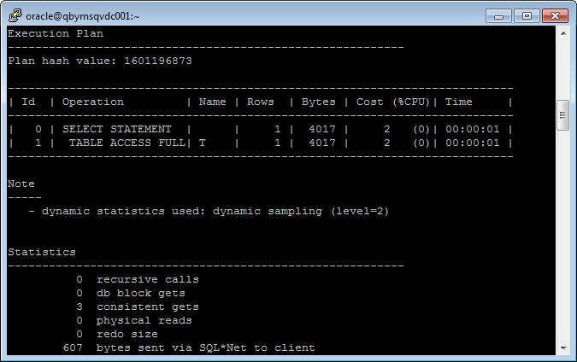

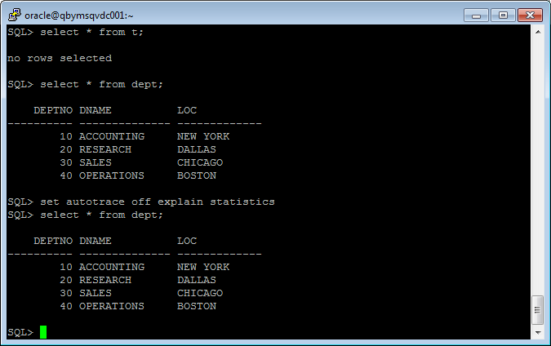

|  |  |  |  |
| --- | --- | --- | --- |
| № | Auto Trace Configuration Options | Expected Results | Description |
| 1 | set autotrace off | Result dataset only | Shows only result set of the query |
| 2 | set autotrace on | Result dataset and execution plan and statistics | Shows result set, execution plan and statistic of the query |
| 3 | set autotracetraceonly | Number of selected rows and execution plan statistics | Shows number of the rows in result set and execution plan with statistics of the query |
| 4 | set autotrace on explain | Result dataset and execution plan | Shows result set and execution of the query |
| 5 | set autotrace on statistics | Result dataset and statistics | Shows result set and statistic of the query |
| 6 | set autotrace on explain statistics | Result dataset and execution plan +statistics | Shows result set, execution plan and statistic of the query |
| 7 | set autotracetraceonly explain | Execution plan only | Shows execution plan only |
| 8 | set autotracetraceonly statistics | Statistics only | Shows statistics only |
| 9 | set autotracetraceonly explain statistics | Execution plan and statistics | Shows execution plan and statistics of the query |
| 10 | set autotrace off explain | Result dataset only | Shows result set only |
| 11 | set autotrace off statistics | Result dataset only | Shows result set only |
| 12 | set autotrace off explain statistics | Result dataset only | Shows result set only |

2. Join Methods

Nested Loops Joins

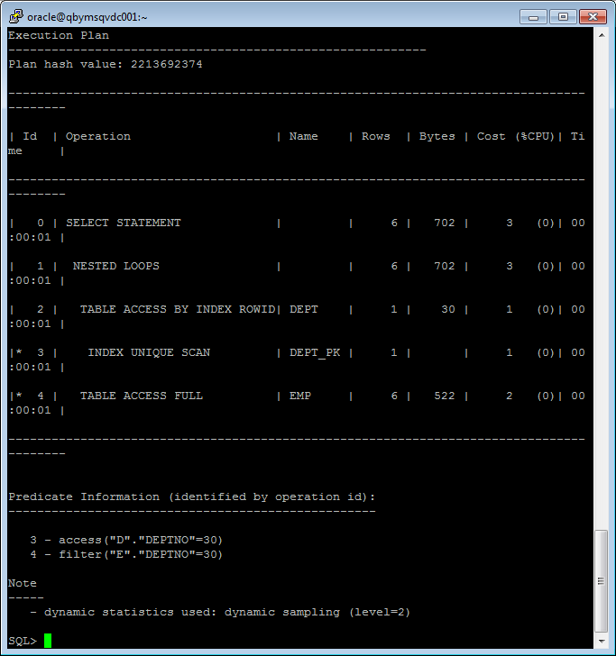

Sort – Merge Joins

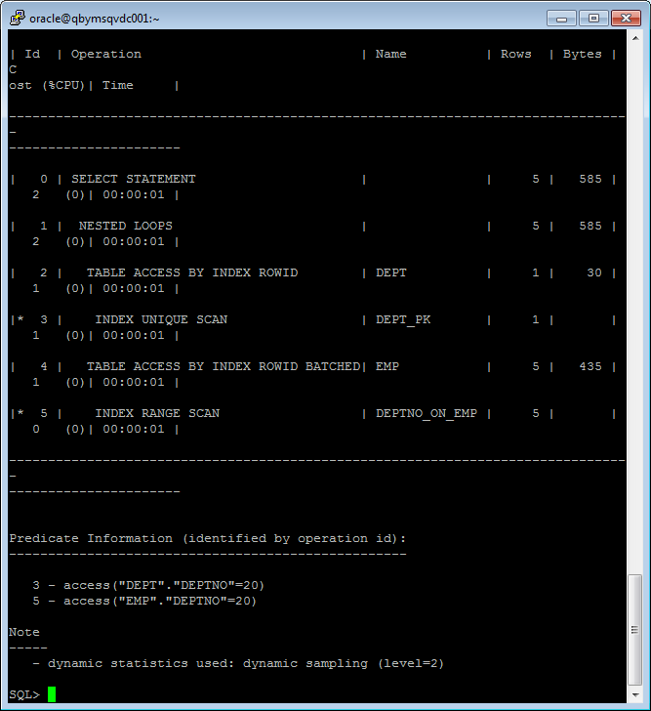

Hash Joins

SELECT *

FROM emp e JOIN dept d USING (deptno)

WHERE deptno > 10;

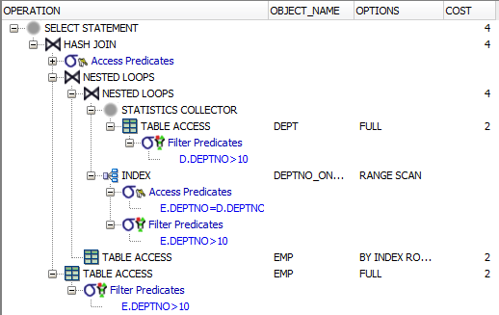

Cartesian Joins

SELECT *

FROM emp e, dept d;

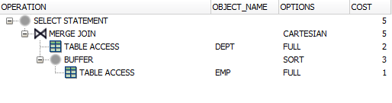

Left/Right Outer Joins

SELECT *

FROM emp e LEFT OUTER JOIN dept d USING (deptno)

WHERE deptno = 10;

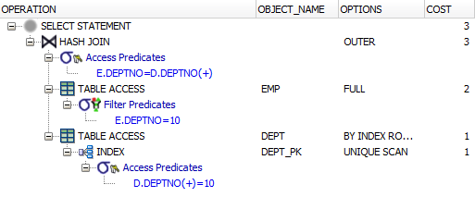

SELECT *

FROM emp e RIGHT OUTER JOIN dept d USING (deptno)

WHERE deptno = 20;

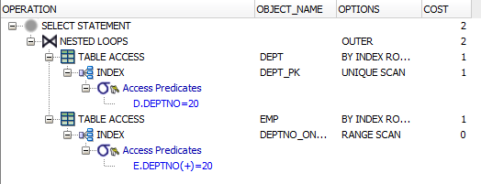

Full Outer Joins

SELECT *

FROM emp e FULL OUTER JOIN dept d USING (deptno)

WHERE deptno = 20;

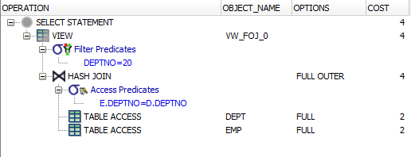

Semi Joins

SELECT *

FROM dept d

WHERE EXISTS (

SELECT *

FROM emp e

WHERE e.deptno = d.deptno);

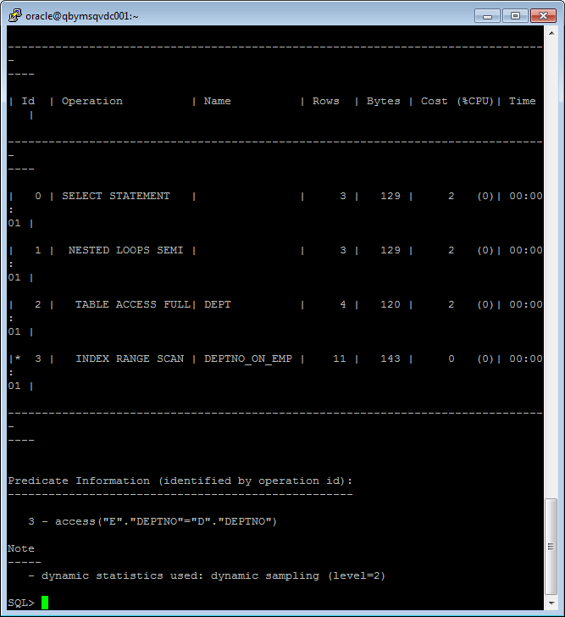

SELECT *

FROM dept d

WHERE EXISTS (

SELECT /*+ MERGE_SJ*/ *

FROM emp e

WHERE e.deptno = d.deptno);

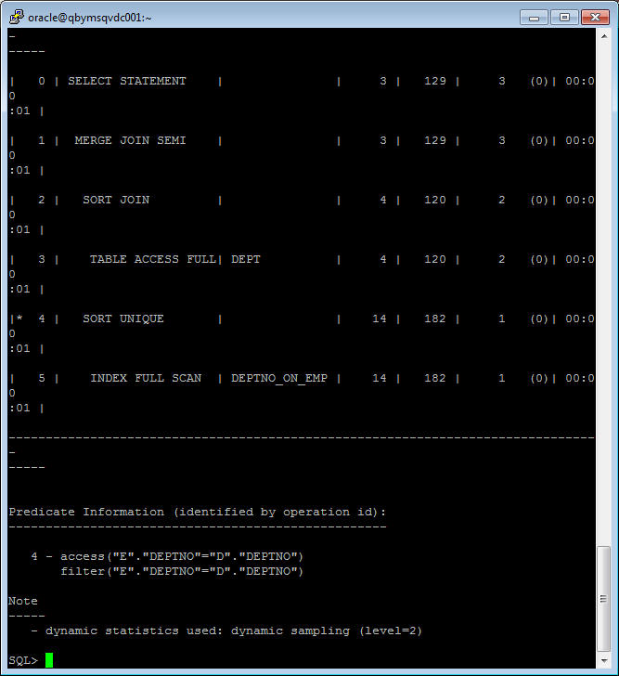

SELECT *

FROM dept d

WHERE EXISTS (

SELECT /*+ hash_SJ*/*

FROM emp e

WHERE e.deptno = d.deptno);

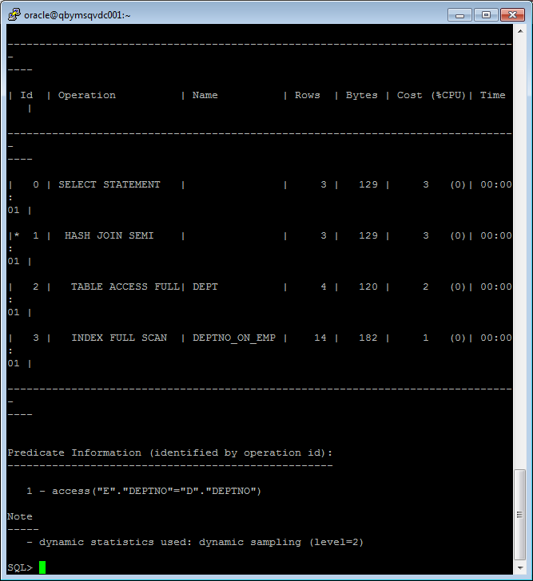

Anti Joins

SELECT *

FROM dept d

WHERE NOT EXISTS (

SELECT *

FROM emp e

WHERE e.deptno = d.deptno);

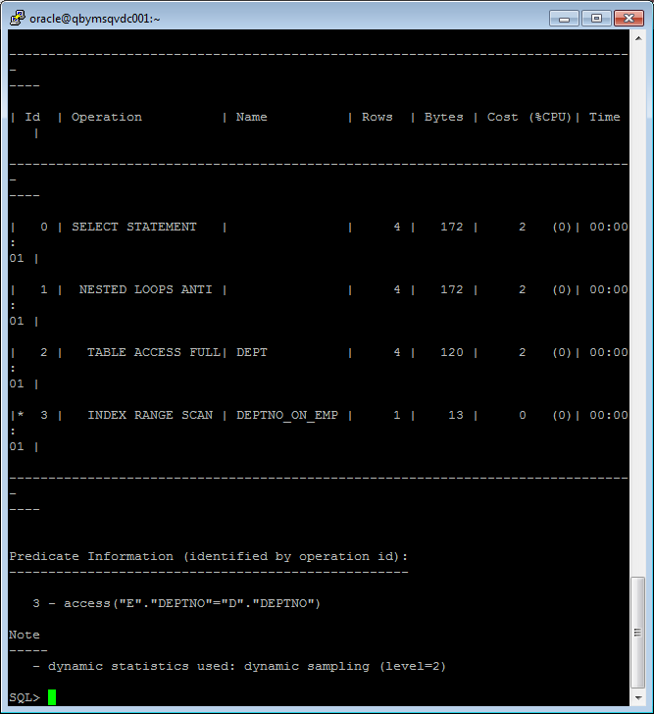

SELECT *

FROM dept d

WHERE NOT EXISTS (

SELECT /*+ HASH_AJ*/*

FROM emp e

WHERE e.deptno = d.deptno);

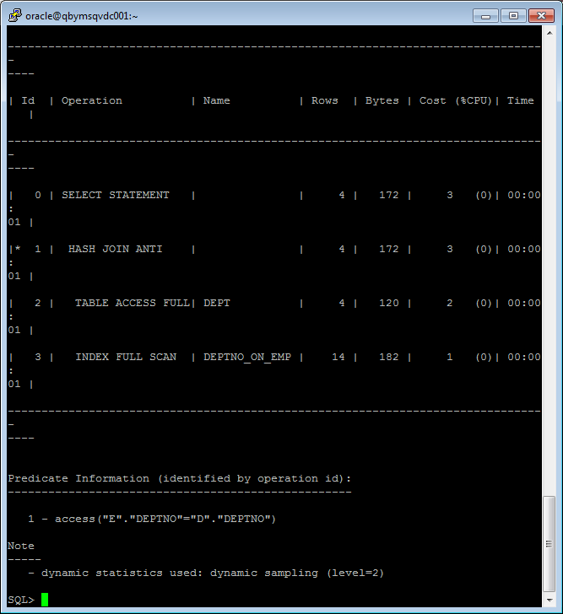

SELECT *

FROM dept d

WHERE NOT EXISTS (

SELECT /*+ MERGE_AJ*/*

FROM emp e

WHERE e.deptno = d.deptno);

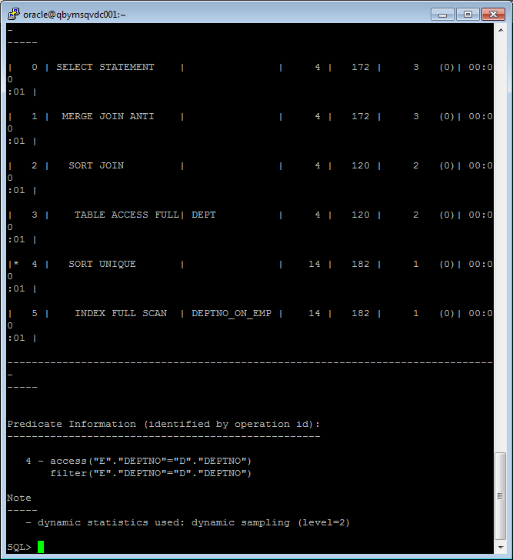

**Summary table**

|  |  |
| --- | --- |
|  | **very good** |
|  | **good** |
|  | **normal** |
|  | **bad** |

|  |  |  |  |  |  |  |
| --- | --- | --- | --- | --- | --- | --- |
| **Join Access “A”** | **Join Access “B”** | **Nested Loop** | **Hash Join** | **Sort-Merge Join** | **Anti-Join** | **Semi-Join** |
| Heap Table (S) | Heap Table (S) |  |  |  |  |  |
| Heap Table (S) | Heap Indexed Table (S) |  |  |  |  |  |
| Heap Indexed Table (S) | Heap Indexed Table (S) |  |  |  |  |  |
| Heap Table (L) | Heap Table (L) |  |  |  |  |  |
| Heap Table (L) | Heap Indexed Table (L) |  |  |  |  |  |
| Heap Indexed Table (L) | Heap Indexed Table (L) |  |  |  |  |  |
| Heap Table (S) | Heap Table (L) |  |  |  |  |  |
| Heap Table (S) | Heap Indexed Table (L) |  |  |  |  |  |
| Heap Indexed Table (S) | Heap Table (L) |  |  |  |  |  |
| Heap Indexed Table (L) | Heap Indexed Table (S) |  |  |  |  |  |